Point on a Surface

Definition
# Source: AI Source: Provided by: [Data Path: Persons Table -> ID Column: 1, Name_En Column: Motasem Essam] -> From: [ChatGPT] on [7/25/2026]
A Point on a Surface is a point that belongs to a given geometric surface in space.
If $P$is a point and $S$is a surface, the containment relationship is written as:
$$\boxed{P∈S}$$
This means that point $P$lies on or is contained in surface $S$.
A surface is a two-dimensional geometric object embedded in three-dimensional space. It may be flat or curved.
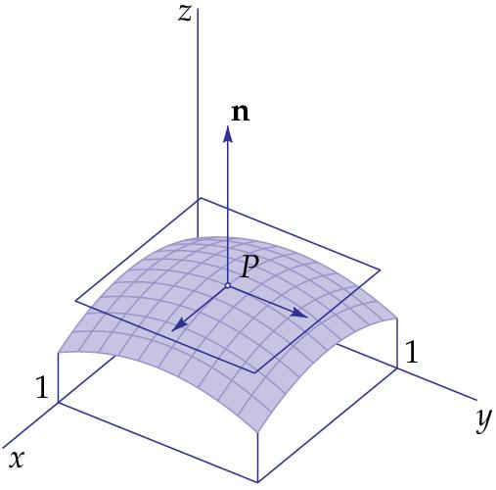
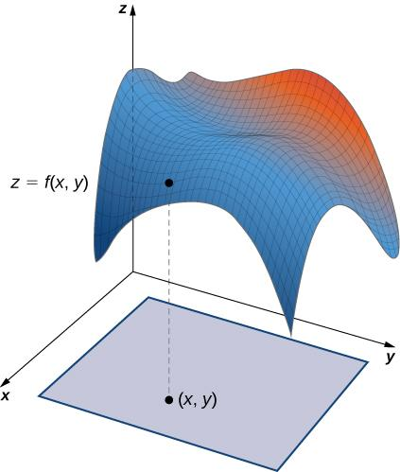
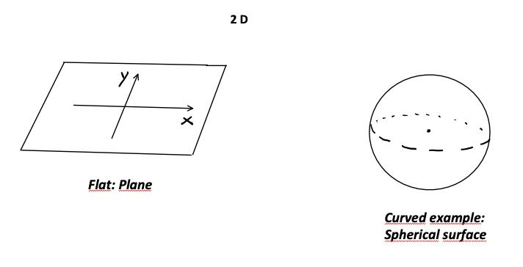
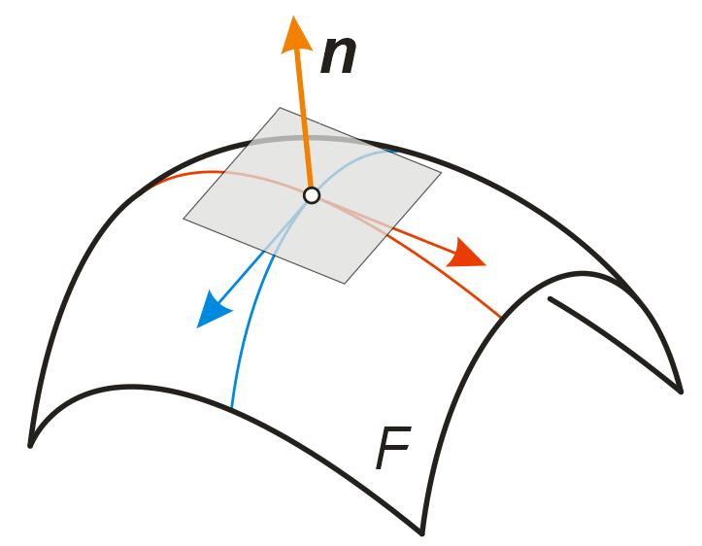
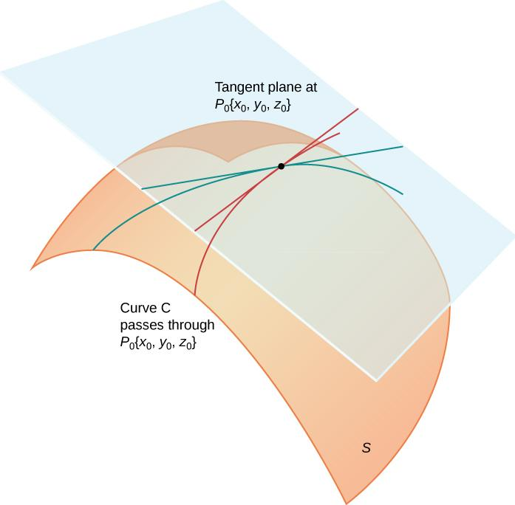

Fundamental Concept
# Source: AI Source: Provided by: [Data Path: Persons Table -> ID Column: 1, Name_En Column: Motasem Essam] -> From: [ChatGPT] on [7/25/2026]
A surface consists of a collection of points arranged continuously in two dimensions within three-dimensional space.
For example:
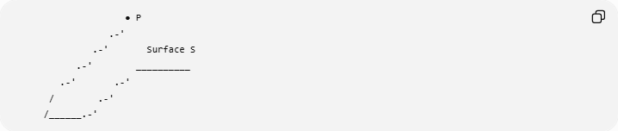
● P
.-'
.-' Surface S
.-' __________
.-' .-'
/ .-'
/______.-'
If $P$lies on the surface:
$$P∈S.$$
If $P$does not lie on the surface:
$$P∉S.$$
The surface may be:
- a plane surface,
- a spherical surface,
- a cylindrical surface,
- a conical surface,
- a toroidal surface,
- or another mathematical surface.

Mathematical Representation
# Source: AI Source: Provided by: [Data Path: Persons Table -> ID Column: 1, Name_En Column: Motasem Essam] -> From: [ChatGPT] on [7/25/2026]
A surface can be represented by an equation:
$$F\left(x , y , z\right)=0.$$
For a point:
$$P=\left(x_{0} , y_{0} , z_{0}\right),$$
the point lies on the surface if:
$$\boxed{F\left(x_{0} , y_{0} , z_{0}\right)=0}$$
Therefore:
$$\boxed{P∈S ⟺ F\left(x_{0} , y_{0} , z_{0}\right)=0}$$
This provides a general coordinate test for point-on-surface containment.

Example: Point on a Spherical Surface
# Source: AI Source: Provided by: [Data Path: Persons Table -> ID Column: 1, Name_En Column: Motasem Essam] -> From: [ChatGPT] on [7/25/2026]
Consider the spherical surface:
$$x^{2}+y^{2}+z^{2}=25.$$
Let:
$$P=\left(3 , 4 , 0\right).$$
Substitute:
$$3^{2}+4^{2}+0^{2}=9+16=25.$$
Therefore:
$$\boxed{P∈S}$$
The point lies on the spherical surface.
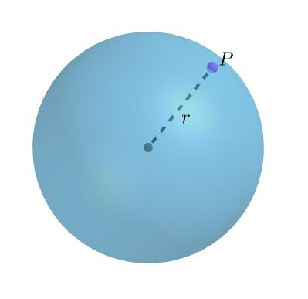
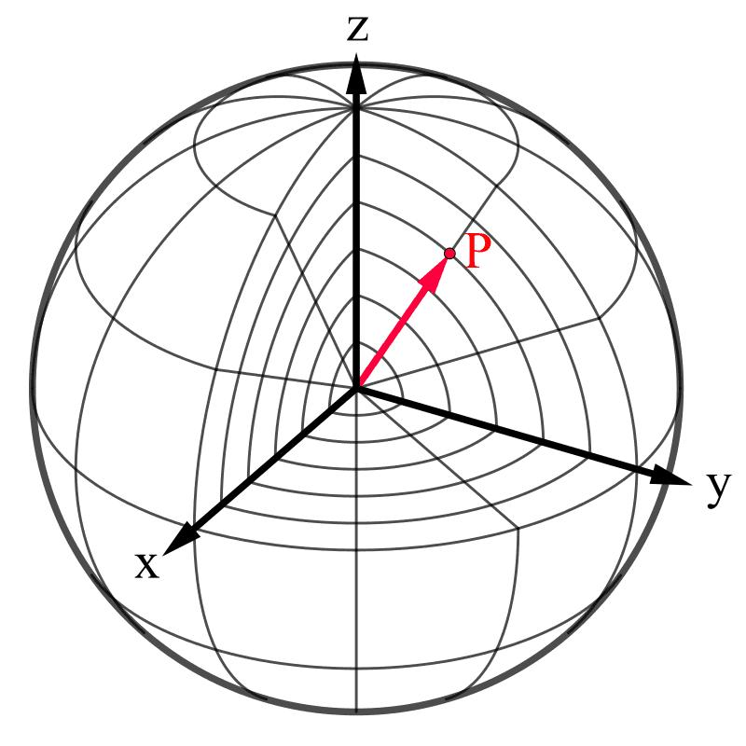
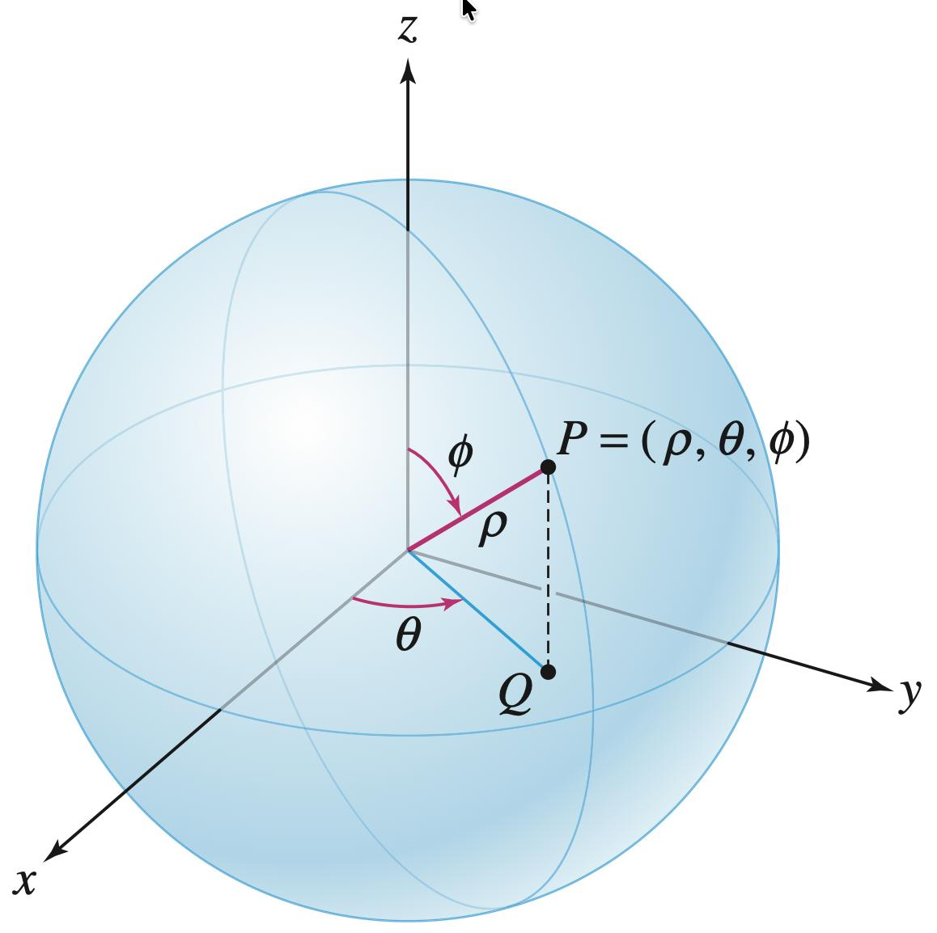
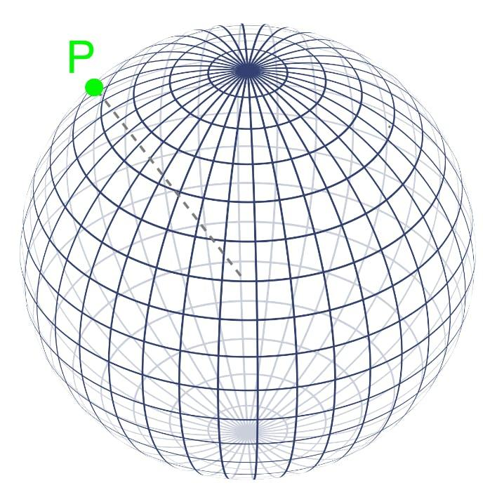
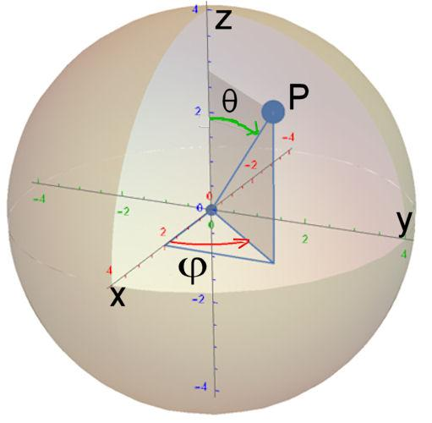

Example: Point Not on the Surface
# Source: AI Source: Provided by: [Data Path: Persons Table -> ID Column: 1, Name_En Column: Motasem Essam] -> From: [ChatGPT] on [7/25/2026]
Using the same spherical surface:
$$x^{2}+y^{2}+z^{2}=25,$$
consider:
$$Q=\left(3 , 4 , 2\right).$$
Then:
$$3^{2}+4^{2}+2^{2}=9+16+4=29.$$
Since:
$$29≠25,$$
we have:
$$\boxed{Q∉S}.$$
The point is not on the spherical surface.

Types of Surfaces Containing a Point

1. Point on a Plane Surface
# Source: AI Source: Provided by: [Data Path: Persons Table -> ID Column: 1, Name_En Column: Motasem Essam] -> From: [ChatGPT] on [7/25/2026]
A plane is a flat surface.
For:
$$ax+by+cz=d,$$
point:
$$P=\left(x_{0} , y_{0} , z_{0}\right)$$
lies on the plane when:
$$\boxed{ax_{0}+by_{0}+cz_{0}=d}.$$
For example, the $xy$-plane is:
$$z=0.$$
Therefore:
$$P=\left(4 , 7 , 0\right)$$
lies on the $xy$-plane.

2. Point on a Spherical Surface
# Source: AI Source: Provided by: [Data Path: Persons Table -> ID Column: 1, Name_En Column: Motasem Essam] -> From: [ChatGPT] on [7/25/2026]
A sphere centered at the origin has surface equation:
$$\boxed{x^{2}+y^{2}+z^{2}=r^{2}}.$$
A point lies on the spherical surface when its distance from the center is exactly $r$.
For example:
$$P=\left(0 , 0 , 5\right)$$
lies on:
$$x^{2}+y^{2}+z^{2}=25.$$

3. Point on a Cylindrical Surface
# Source: AI Source: Provided by: [Data Path: Persons Table -> ID Column: 1, Name_En Column: Motasem Essam] -> From: [ChatGPT] on [7/25/2026]
A circular cylindrical surface whose axis is the $z$-axis can be represented by:
$$\boxed{x^{2}+y^{2}=r^{2}}.$$
For example, with:
$$r=3,$$
the point:
$$P=\left(3 , 0 , 7\right)$$
lies on the cylinder because:
$$3^{2}+0^{2}=9.$$
The $z$-coordinate can vary along the cylinder.
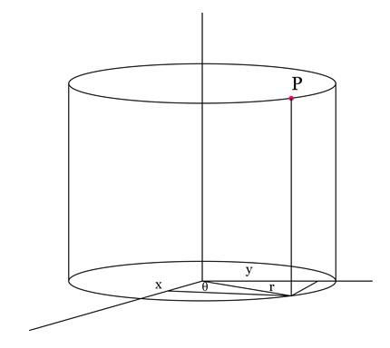
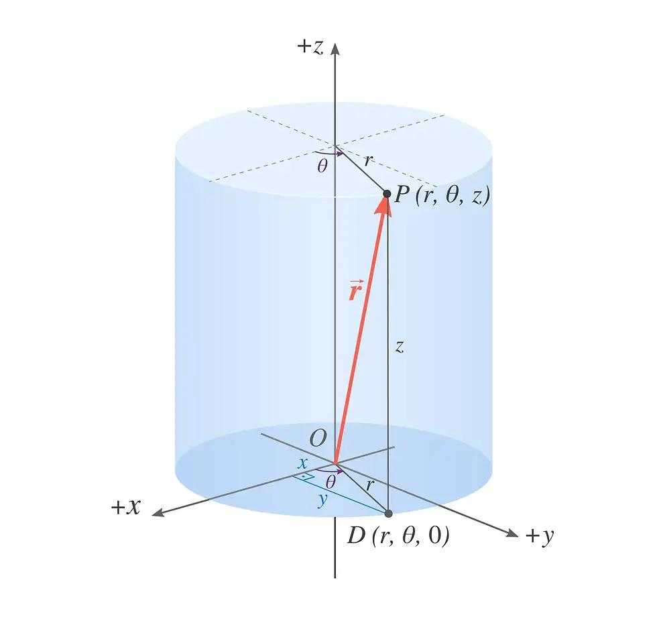
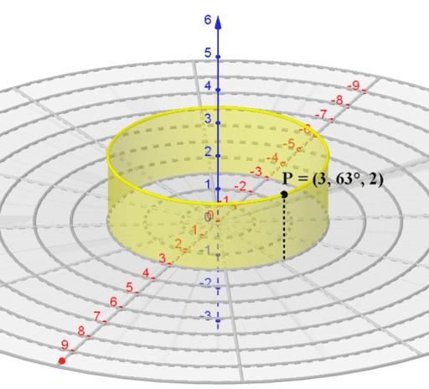
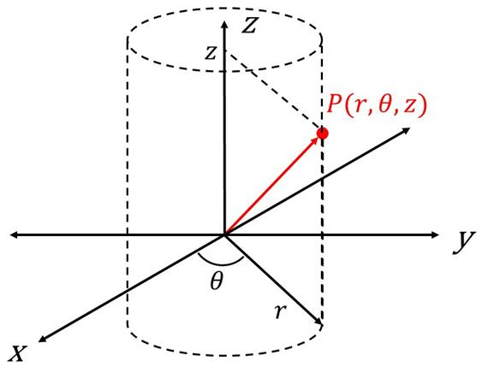
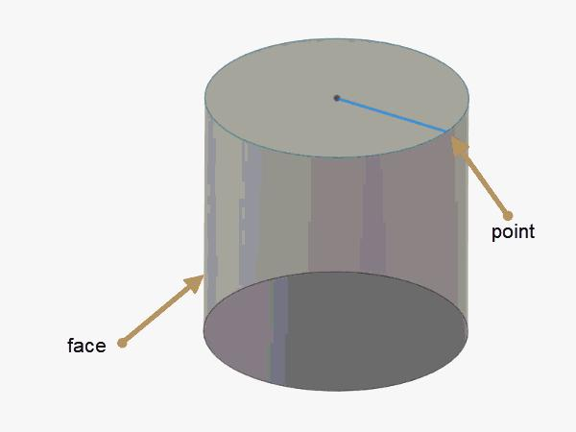

4. Point on a Conical Surface
# Source: AI Source: Provided by: [Data Path: Persons Table -> ID Column: 1, Name_En Column: Motasem Essam] -> From: [ChatGPT] on [7/25/2026]
A right circular cone with vertex at the origin and axis along the $z$-axis can be represented by an equation such as:
$$x^{2}+y^{2}=k^{2}z^{2}.$$
A point satisfying this equation lies on the conical surface.
For example, for:
$$x^{2}+y^{2}=z^{2},$$
consider:
$$P=\left(3 , 4 , 5\right).$$
Then:
$$3^{2}+4^{2}=25$$
and:
$$5^{2}=25.$$
Therefore:
$$\boxed{P∈S}.$$

5. Point on a Toroidal Surface
# Source: AI Source: Provided by: [Data Path: Persons Table -> ID Column: 1, Name_En Column: Motasem Essam] -> From: [ChatGPT] on [7/25/2026]
A standard ring torus can be represented by:
$${\left(\sqrt{x^{2}+y^{2}}-R\right)}^{2}+z^{2}=r^{2}.$$
A point belongs to the toroidal surface when its coordinates satisfy this equation.
For a torus with:
$$R=5, r=2,$$
consider:
$$P=\left(7 , 0 , 0\right).$$
Then:
$${\left(\sqrt{7^{2}+0^{2}}-5\right)}^{2}+0^{2} \\ ={\left(7-5\right)}^{2} \\ =4$$
and:
$$r^{2}=2^{2}=4.$$
Therefore:
$$\boxed{P∈S}.$$

Surface vs Solid
# Source: AI Source: Provided by: [Data Path: Persons Table -> ID Column: 1, Name_En Column: Motasem Essam] -> From: [ChatGPT] on [7/25/2026]
This distinction is very important.
Consider a sphere with radius $r$.
Spherical Surface
$$\boxed{x^{2}+y^{2}+z^{2}=r^{2}}$$
Only points exactly at distance $r$from the center belong to the surface.
Solid Sphere
$$\boxed{x^{2}+y^{2}+z^{2}≤r^{2}}$$
This includes:
- the surface,
- the interior.
Therefore:
$$\text{Point on spherical surface}≠\text{Point inside solid sphere}.$$
For example, with $r=5$:
$$P=\left(3 , 4 , 0\right)$$
satisfies:
$$3^{2}+4^{2}=25,$$
so it is on the surface.
But:
$$Q=\left(1 , 1 , 1\right)$$
satisfies:
$$1+1+1=3<25,$$
so $Q$is inside the solid, not on the spherical surface.

Point on a Surface vs Point Inside a Region
# Source: AI Source: Provided by: [Data Path: Persons Table -> ID Column: 1, Name_En Column: Motasem Essam] -> From: [ChatGPT] on [7/25/2026]
These are also different containment relationships.
Point on a Surface
$$\boxed{P∈S}$$
The point lies directly on the surface.
Point Inside a Region
$$\boxed{P∈int⁡\left(R\right)}$$
The point lies strictly inside a region.
For a circle:
$$x^{2}+y^{2}=r^{2}$$
describes its boundary, while:
$$x^{2}+y^{2}<r^{2}$$
describes its interior.
Thus:
$$\boxed{\text{Surface/boundary}≠\text{Interior}}$$

Point on a Surface vs Point in a Plane
# Source: AI Source: Provided by: [Data Path: Persons Table -> ID Column: 1, Name_En Column: Motasem Essam] -> From: [ChatGPT] on [7/25/2026]
A plane is a particular type of flat surface.
Therefore, if:
$$P∈Π$$
where $Π$is a plane, then $P$lies on that plane surface.
However, not every surface is a plane.
For example:
$$\text{Sphere}, \text{Cylinder}, \text{Cone}, \text{Torus}$$
are curved surfaces.
So:
$$\boxed{\text{Plane}⊂\text{Surface}}$$
when considering plane as a particular type of surface.

Point on a Surface vs Point on a Line
# Source: AI Source: Provided by: [Data Path: Persons Table -> ID Column: 1, Name_En Column: Motasem Essam] -> From: [ChatGPT] on [7/25/2026]
A line is one-dimensional, while a surface is two-dimensional.
For example:
$$P∈l$$
means that $P$lies on line $l$.
Meanwhile:
$$P∈S$$
means that $P$lies on surface $S$.
If a line lies entirely on a surface:
$$l⊆S,$$
then every point of that line also belongs to the surface:
$$P∈l⇒P∈S.$$

Distance Interpretation
# Source: AI Source: Provided by: [Data Path: Persons Table -> ID Column: 1, Name_En Column: Motasem Essam] -> From: [ChatGPT] on [7/25/2026]
For a point $P$on a surface $S$, the point's distance to the surface is:
$$\boxed{d\left(P , S\right)=0}.$$
For example, if $P$lies on a sphere of radius $r$, its distance from the sphere's center $O$is exactly:
$$OP=r.$$
But for a general surface, the most useful criterion is:
$$\boxed{d\left(P , S\right)=0}.$$

Parametric Representation
# Source: AI Source: Provided by: [Data Path: Persons Table -> ID Column: 1, Name_En Column: Motasem Essam] -> From: [ChatGPT] on [7/25/2026]
A surface can also be represented parametrically:
$$r\left(u , v\right)=\left(x , \left(u , v\right) , y\left(u , v\right)z\left(u , v\right)\right).$$
A point $P$lies on the surface if there exist parameters $u,v$such that:
$$\boxed{P=r\left(u , v\right)}.$$
For example, a sphere can be parameterized as:
$$x=r\sin{ϕ}\cos{θ} \\ y=r\sin{ϕ}\sin{θ} \\ z=r\cos{ϕ}.$$
Every point generated by appropriate values of $θ$and $ϕ$lies on the spherical surface.

Surface Containment and Boundary
# Source: AI Source: Provided by: [Data Path: Persons Table -> ID Column: 1, Name_En Column: Motasem Essam] -> From: [ChatGPT] on [7/25/2026]
A surface may be the boundary of a three-dimensional solid.
For a solid $V$, its boundary can be represented as:
$$∂V.$$
If:
$$P∈∂V,$$
then $P$lies on the boundary surface of the solid.
For a sphere:
$$∂V=\left\{\left(x , y , z\right):x^{2}+y^{2}+z^{2}=r^{2}\right\}.$$
Thus:
$$P∈∂V$$
means that $P$lies on the spherical surface.

Open and Closed Surfaces
# Source: AI Source: Provided by: [Data Path: Persons Table -> ID Column: 1, Name_En Column: Motasem Essam] -> From: [ChatGPT] on [7/25/2026]
A point can lie on either an open or closed surface.
Open Surface
Examples include:
- lateral surface of a cylinder without bases,
- lateral surface of a cone without its base,
- curved surface of a hemisphere without its base.
A point may belong to such a surface even though the surface has a boundary.
Closed Surface
Examples include:
- spherical surface,
- complete toroidal surface,
- complete cylinder including its bases,
- complete cone including its base.
The point-on-surface relationship remains:
$$P∈S.$$
Whether the surface is open or closed is a separate classification.

Examples

Example 1 — Plane
# Source: AI Source: Provided by: [Data Path: Persons Table -> ID Column: 1, Name_En Column: Motasem Essam] -> From: [ChatGPT] on [7/25/2026]
Plane:
$$2x+y+3z=12.$$
Point:
$$P=\left(1 , 2 , 3\right).$$
Check:
$$2\left(1\right)+2+3\left(3\right)=2+2+9=13.$$
Since:
$$13≠12, \\ \boxed{P∉S}.$$

Example 2 — Sphere
# Source: AI Source: Provided by: [Data Path: Persons Table -> ID Column: 1, Name_En Column: Motasem Essam] -> From: [ChatGPT] on [7/25/2026]
Surface:
$$x^{2}+y^{2}+z^{2}=36.$$
Point:
$$P=\left(2 , 4 , 4\right).$$
Check:
$$2^{2}+4^{2}+4^{2}=4+16+16=36.$$
Therefore:
$$\boxed{P∈S}.$$

Example 3 — Cylinder
# Source: AI Source: Provided by: [Data Path: Persons Table -> ID Column: 1, Name_En Column: Motasem Essam] -> From: [ChatGPT] on [7/25/2026]
Surface:
$$x^{2}+y^{2}=16.$$
Point:
$$P=\left(0 , 4 , 10\right).$$
Check:
$$0^{2}+4^{2}=16.$$
Therefore:
$$\boxed{P∈S}.$$

Relationship with Related Concepts
# Source: AI Source: Provided by: [Data Path: Persons Table -> ID Column: 1, Name_En Column: Motasem Essam] -> From: [ChatGPT] on [7/25/2026]
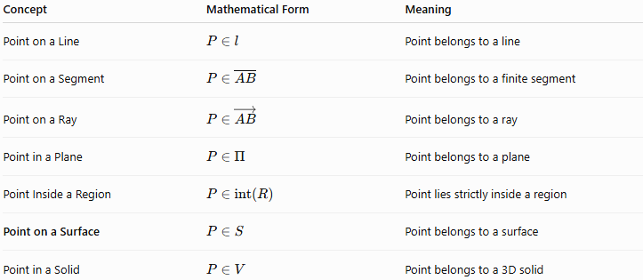
Concept | Mathematical Form | Meaning
Point on a Line | $$P∈l$$ | Point belongs to a line
Point on a Segment | $$P∈\overset{‾}{AB}$$ | Point belongs to a finite segment
Point on a Ray | $$P∈\vec{AB}$$ | Point belongs to a ray
Point in a Plane | $$P∈Π$$ | Point belongs to a plane
Point Inside a Region | $$P∈int⁡\left(R\right)$$ | Point lies strictly inside a region
Point on a Surface | $$P∈S$$ | Point belongs to a surface
Point in a Solid | $$P∈V$$ | Point belongs to a 3D solid

Surface Types Related to Point Containment
# Source: AI Source: Provided by: [Data Path: Persons Table -> ID Column: 1, Name_En Column: Motasem Essam] -> From: [ChatGPT] on [7/25/2026]
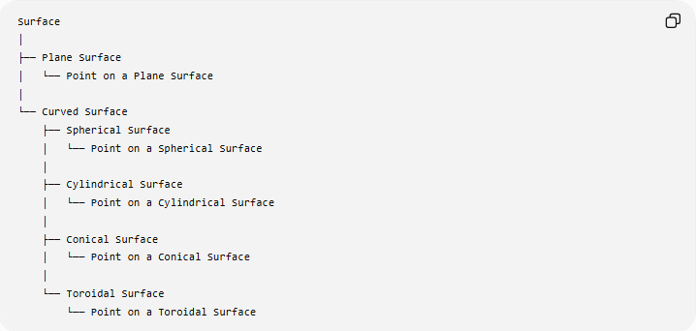
Surface
│
├── Plane Surface
│ └── Point on a Plane Surface
│
└── Curved Surface
├── Spherical Surface
│ └── Point on a Spherical Surface
│
├── Cylindrical Surface
│ └── Point on a Cylindrical Surface
│
├── Conical Surface
│ └── Point on a Conical Surface
│
└── Toroidal Surface
└── Point on a Toroidal Surface

Key Points
# Source: AI Source: Provided by: [Data Path: Persons Table -> ID Column: 1, Name_En Column: Motasem Essam] -> From: [ChatGPT] on [7/25/2026]
- A Point on a Surface is a point that belongs to a geometric surface.
- The fundamental notation is:
$$\boxed{P∈S}.$$
- A general surface can be represented by:
$$F\left(x , y , z\right)=0.$$
- A point $P=\left(x_{0} , y_{0} , z_{0}\right)$lies on the surface when:
$$F\left(x_{0} , y_{0} , z_{0}\right)=0.$$
- A surface may be flat or curved.
- A plane is a special type of flat surface.
- Spheres, cylinders, cones, and tori are examples of curved surfaces.
- A point on a surface is different from a point inside the solid bounded by that surface.
- For a boundary surface:
$$d\left(P , S\right)=0.$$
- Surface classification as open or closed is independent of whether the surface is plane or curved.
- Point-on-surface containment is fundamental to solid geometry, analytic geometry, coordinate geometry, vectors, 3D modeling, CAD, computer graphics, and spatial analysis.

Conclusion
# Source: AI Source: Provided by: [Data Path: Persons Table -> ID Column: 1, Name_En Column: Motasem Essam] -> From: [ChatGPT] on [7/25/2026]
Point on a Surface describes the containment relationship in which a point belongs to a two-dimensional geometric surface embedded in three-dimensional space. The surface may be plane or curved, and the point can be verified mathematically by substituting its coordinates into the surface equation. This concept connects point containment with planes, curved surfaces, boundaries, solids, coordinate geometry, and three-dimensional spatial geometry.
Would you like the next entry to cover a point inside a solid or a point outside a surface?

